LLTF CONTRAST

User Manual

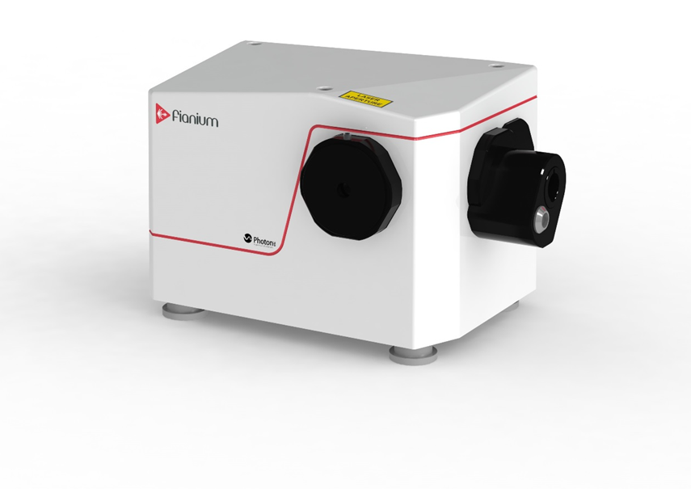

Contents

Laser Safety 3

A. Introduction 4

Labels Fixed to this Unit 4

Label Positions 4

B. Technology Overview 5

C. Environmental Considerations 5

D. Requirements 6

PHySpec System Requirements 6

Software/Driver Installation 6

E. Before Using the Instrument 7

Visual Inspection 7

Optical Alignment 8

Installation of Fiber Coupling Module 10

Alignment Using Fiber Delivery System 12

Using Fiber Alignment Tool 13

F. Instrument Control 15

Starting and Configuring the Instrument 15

G. Wavelength Calibration 17

Manual Calibration 17

H. Sequencer 19

Variables 19

Actions 20

I. Maintenance 23

Basic cleaning instructions 23

J. Troubleshooting 24

### Laser Safety



**CAUTION**: Use of controls or adjustments or performance of procedures other than those specified herein may result in hazardous radiation exposure.

The laser beam is emitted from the side of the LLTF where the laser aperture labels are fixed. This is a collimated beam.

The LLTF safety interlock can be connected into your existing interlocks if required. This is the wire loop in the 15-pin D plug connector supplied with the system. For the system to be operated the interlock cable is required to be attached to the filter unit and the laser lens tube inserted fully into the input housing in order for the interlock to be enabled.

If the interlock is opened (if for example the laser output lens tube is removed from the LLTF during operation), the laser will be shut off.

The LLTF is a sealed unit. There is no reason to open the unit. The removal of any panels will invalidate the warranty. Never remove the output cap when the instrument is powered.

Note: This equipment has been tested and found to comply with the limits for a **Class A** digital device, pursuant to **part 15 of the FCC Rules**. These limits are designed to provide reasonable protection against harmful interference when the equipment is operated in a commercial environment. This equipment generates, uses, and can radiate radio frequency energy and, if not installed and used in accordance with the instruction manual, may cause harmful interference to radio communications.

# Introduction

When supercontinuum light is launched in to the input port of the filter, a filtered laser beam is emitted at the output port of the instrument. The manual for the PHySpec software made for your instrument or system is also covered in this user manual.

### Labels Fixed to this Unit



Label A: Laser warning triangle



Label B: Laser aperture label



Label C: Classification label

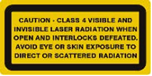

Label D: Classification label



Label E: Refer to manual label

### Label Positions

Label **A** and **B** are fixed to the top cover, close to the optical output.

Label **C** is fixed to the top cover

Label **D** is fixed on the input port

Label **E** is fixed on the LLTF front face, close to the power switch.

# Technology Overview

The Laser Line Tunable Filter is based on the Bragg Tunable Filter (BTF) technology.. The instrument makes it possible to select a monochromatic beam at a wavelength specified by the user. A calibration procedure ensures that the proper wavelength is produced by the instrument at any given time.

# Environmental Considerations

The following conditions are required to obtain the specifications of your instrument and to maximize its lifetime:

* The instrument is primarily designed for controlled laboratory environments.
* The operating temperature should always be between 5⁰C and 40⁰C. The storage temperature should always be between 0⁰C and 50⁰C.
* Spectral calibration of the instrument will be affected by temperature change. Typically, one should expect an average change in wavelength of 0.01nm/⁰C.
* Even if the instrument is rugged and compact, its performance depends on the surface stability. We strongly recommend an environment free of vibrations during the operation of the instrument.
* Mechanical shocks during handling are prohibited. The instrument is not compliant with any shock standards.
* The instrument should be used in an upright position. Changing the orientation may affect the operation of the rotating parts allowing the wavelength tuning.

# Requirements

## PHySpec System Requirements

* + Computer with Windows XP SP2, Vista or 7 or 8 is required for PHySpec;
  + Computer with a USB port available;
  + Minimum 512Mb of memory available;
  + Hard disk with at least 100 Mb of available space for temporary storage.

## Software/Driver Installation

1. Insert the Fianium USB drive into the computer.
2. Run PHySpec_x.x.x-setup.exe, where x.x.x stands for the PHySpec version.
3. Connect the instrument to the computer with the USB cable. It will be automatically detected.
4. Follow the instructions shown on the screen.
5. Once PHySpec is installed, remove the USB drive.
6. Once the software and drivers are installed, begin section *Starting the Instrument.*

# Before Using the Instrument

## Visual Inspection

Before using the instrument for the first time, we suggest to inspect the instrument for visible evidence of any damage, especially electrical and optical ports shown in Figure E‑1, Figure E‑2 and Figure E‑3. Please note that the AUX 1 and AUX2 are not available for the Laser Line Tunable Laser. Do not operate the instrument if there are any unusual observations, please contact Fianium.

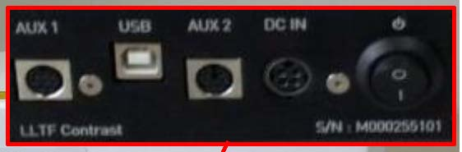

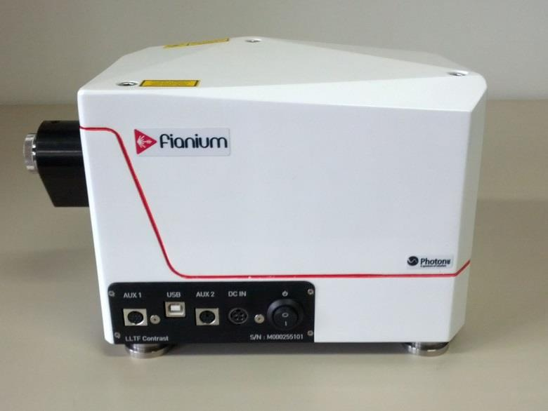

Figure E‑1

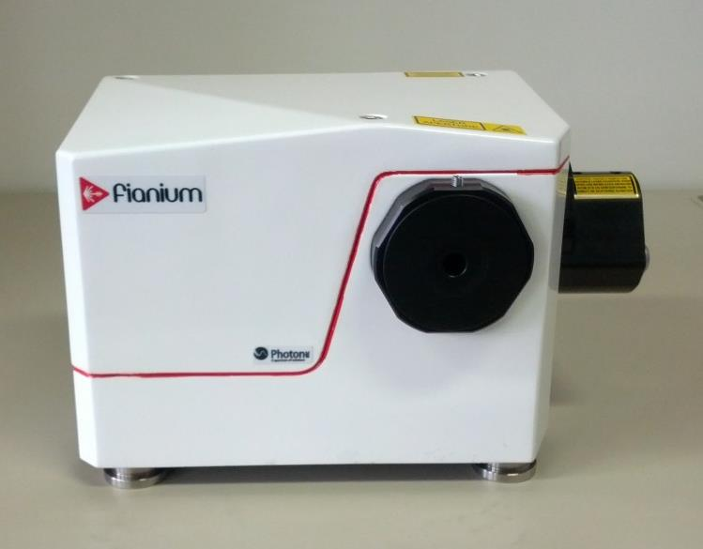

Figure E‑2

Figure E‑3

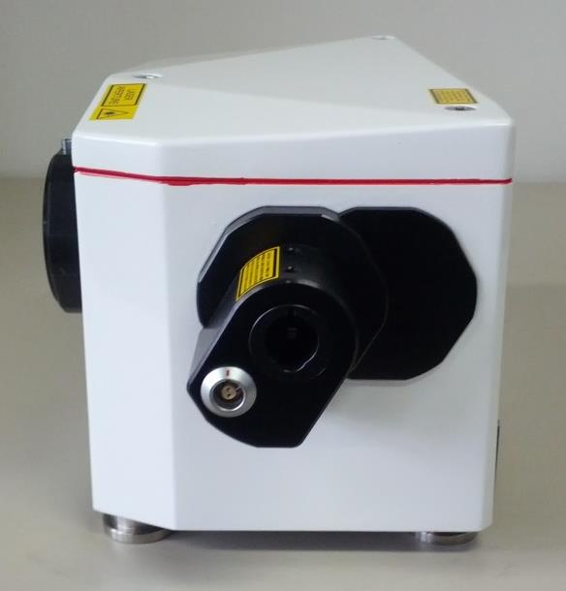

## Optical Alignment

We suggest reading carefully and conforming to the *Environmental Considerations* and *System Requirements* for best performance.

Before installation, a laser safety assessment should be performed to determine the appropriate safety measures to apply (laser safety goggles, laser protective barriers and curtains, pertinent sign information etc. as specified in standard IEC 60825-1).



WARNING: PRIOR TO CONNECTING THE LASER TO THE LASER LINE TUNABLE FILTER, MAKE SURE THAT THE LASER IS NOT IN OPERATION, AND NO LIGHT IS EMITTED FROM THE LASER.

1. Identify the Alignment key of the Fianium laser collimator, and the Alignment lock of the input port of the LLTF (Figure E‑4).

2. Carefully insert the Fianium laser collimator into the input port of the LLTF, by maintaining proper alignment of the Alignment key and Alignment lock (Figure E‑5).

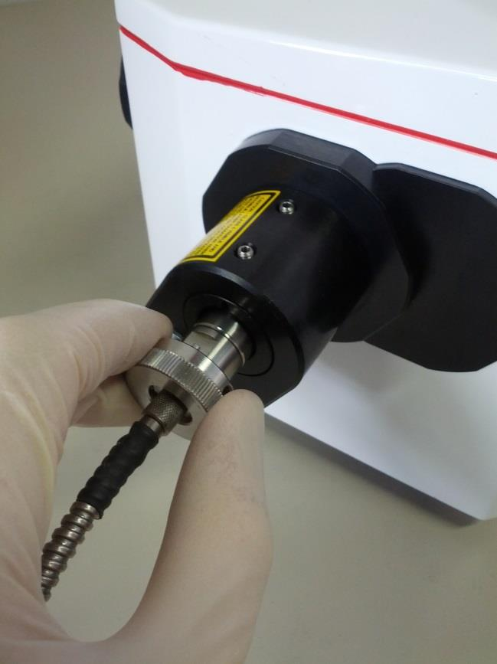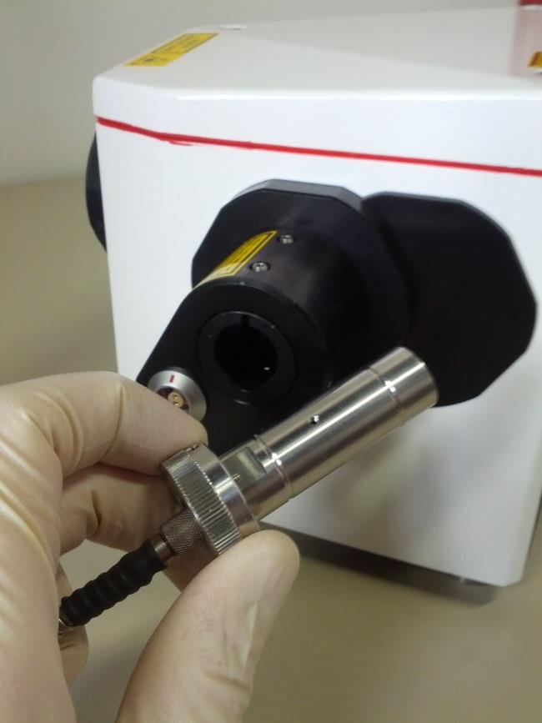

Figure E‑4

Figure E‑5

3. When the Fianium laser collimator is fully inserted into the input port, secure this by tightening the two set screw on the top of the input port (Figure E‑6), by using a 2mm Allen key.

4. Connect the interlock mechanism with the Interlock connector supplied with the Laser Line Tunable Filter.

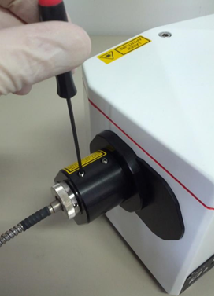

Figure E‑6



WARNING: DO NOT REMOVE THE COLLIMATOR WHEN THE LASER IS IN OPERATION. IT COULD RESULT IN INJURIES AND DAMAGE OF BOTH THE LASER AND THE LLTF

## TriangleInstallation of Fiber Coupling Module

WARNING: PRIOR TO CONNECTING THE OPTIONAL OUTPUT FIBER MODULE TO THE LASER LINE TUNABLE FILTER, MAKE SURE THAT THE **LASER** IS NOT IN OPERATION, AND NO LIGHT IS EMITTED FROM THE LASER. ALSO MAKE SURE THAT THE **UNIT** IS TURNED OFF USING THE POWER SWITCH ON THE FRONT FACE.

1. Remove the output cap using a 3mm Allen key.



Figure E‑7

1. Identify the Alignment keyof the Laser Line Tunable Filter, and the Alignment lockof the fiber alignment module (Figure E-8).

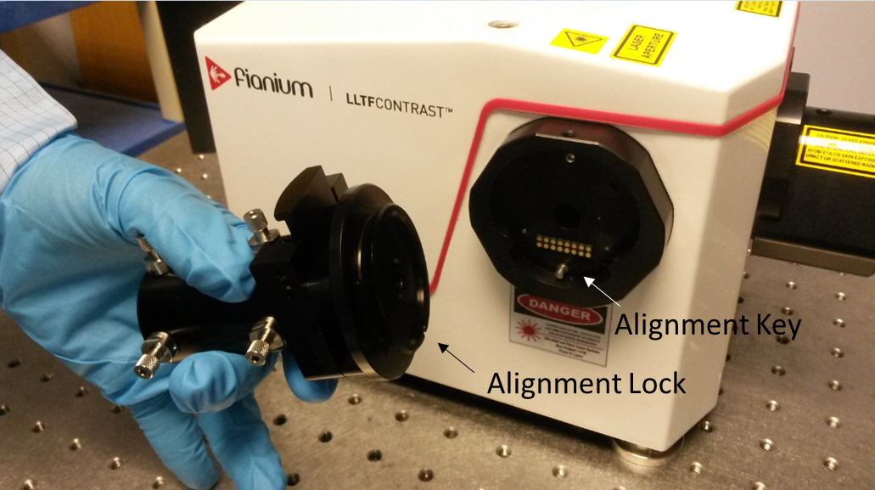

Figure E‑8

3. Carefully insert the fiber coupling module into the output port of the LLTF, by maintaining proper alignment of the Alignment key and Alignment lock. When the fiber coupling module is fully inserted into the output port, secure the module by tightening the set screw on the top of the output port (Figure E‑9), by using a3mm Allen key.

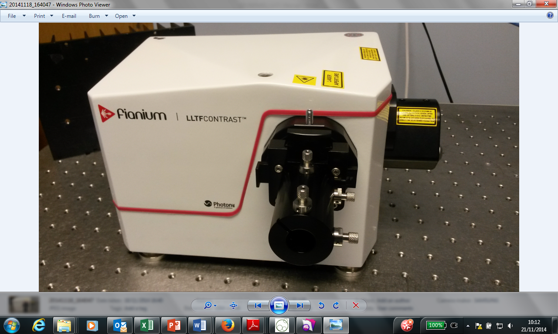

Figure E‑9

## Alignment Using Fiber Delivery System

Depending on your system configuration, you may have been provided with one, two or three fiber collimator/focussing packages (fiber delivery system FDS) which can be inserted into the manipulator.

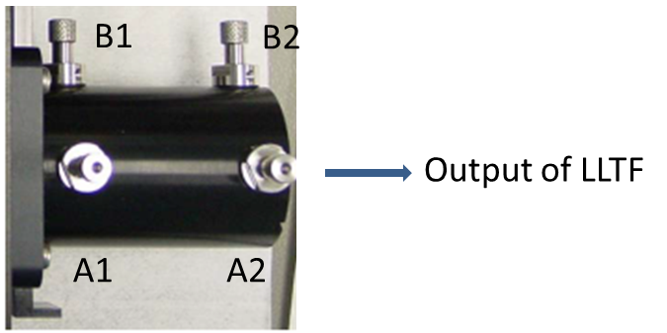

Figure E‑10

Select a wavelength of interest using the GUI (see section Instrument Control) and open the shutter of the manipulator and insert the fiber input lens tube (fitted with an alignment key) into the manipulator, such that the alignment notch of the alignment ring fits into the alignment hole on the manipulator.

Position the output lens tube of the fiber towards a power meter head (consider the laser safety implications) and open the shutter on the manipulator.

Maximise the output power of the fiber, by adjusting the adjustor screws labelled A1/2 and B1/2 in figure E-10. The adjustor pins A1 and A2 change the vertical position and tilt of the lens tube, while B1 and B2 change the horizontal position and tilt. Move A1 and A2 clockwise (as viewed along the direction of the arrow shown in figure E-10) together in order to scan the lens tube downwards, and B1 and B2 clockwise together in order to scan the lens tube to the left. Optimising the fiber coupling is an iterative process that can take many cycles of vertical and horizontal adjustment – follow the guidelines below for maximizing the coupling efficiency:

Adjust B1 by a ½ turn clockwise. Then adjust B2 by a ½ turn clockwise. If the output power is higher than before then the LLTF output and the fiber input are becoming better aligned in the horizontal plane. Continue walking the lens tube in this direction until you reach a maximum output.

If the power is getting lower then repeat the process but this time turning the screws anti-clockwise.

Now use the same walking process on screws A1 and A2.

As you get closer to the optimum output you will find that you have to go from adjusting A1/2 to B1/2 and then back to A1/2. It may be necessary to adjust the position of the central spring pin in order to achieve the optimum position of the fiber lens tube (max output power). This can be done easily using your fingers to **rotate the pin, as appropriate.**

## Using Fiber Alignment Tool

If using a fiber delivered LLTF, you would have been provided with a fiber alignment tool, which is a 50mm long tool with a pinhole located towards one end. If you are using a visible LLTF and absolutely no light can be detected at the output lens tube of the delivery fiber (FDS), it may be necessary to check the rough position of the fiber lens tube with respect to the output axis of the LLTF. If so, please follow the following instructions:

1. Select wavelength 633nm for alignment of first grating with FDS 1, and 700nm for alignment of second grating with FDS 2. This should be sufficient for generating visible light, which can be readily seen on a white card.

2. Remove the FDS lens tube from the output manipulator of the LLTF. Open the output shutter and shine the output onto a plain white card – red light should appear on the card. If no light appears from the LLTF when no fiber is present in the output manipulator (free space output operation), check that the LLTF is correctly setup.

3. Insert the fiber alignment tool into the manipulator, such that the pin hole is located furthest away from the LLTF. Open the shutter, and scan the alignment tool using A2 and B2 adjusts only iteratively to maximize red light exiting the pin hole. You can also use a power meter to maximise the power through the pin hole.

4. Close the shutter the manipulator, remove the alignment tool, and re-insert the tool such that the pin hole is positioned closest to the LLTF unit.

5. Open the shutter, and scan the alignment tool using A1 and B1 adjusts only iteratively to maximize the red light at the output of the pin.

6. Iteratively repeat instructions 3-5 to maximize the light seen coming out of the alignment tool pin hole. This ensures a rough degree of co-alignment between the LLTF output and the position of the LLTF output manipulator.

7. Remove the alignment tool and re-insert the fiber input lens tube into the LLTF output manipulator. Open shutter of the LLTF output and re-check the output of the fiber for optical alignment. Follow the instructions given at the beginning of this section for optimizing the fiber alignment for maximum power.

**This alignment procedure may take some time, even for a skilled operator, depending on how far out the alignment of the fiber is from the LLTF output axis.**

**If using an LLTF-SWIR**, since the lowest wavelength achievable is ~1000nm, the above white card procedure will not work. Substituting the white card for an IR card is unlikely to work, since the minimum IR power required for the IR card to fluoresce may be too high to allow the coarse alignment. Thus, this alignment procedure is best performed using an accurate IR power meter, capable of recording nanowatts or microwatts of IR radiation.

If after following this alignment procedure no output power from the fiber can be achieved, please contact Fianium Support.

# Instrument Control

## Starting and Configuring the Instrument

1. The instrument requires a connection to an AC power source of 100/240V (50/60Hz).

2. Make sure the USB cable is connected to a control computer and THEN turn the instrument ON with the ON/OFF switch. Connecting the instrument after turning it ON will initiate a passive mode and result in communication problems between your instrument and the computer.

3. Start PHySpec using the shortcut on the desktop. Connect to the instrument by selecting the ***System*** menu and then ***Connect.*** Choose your LLTF System (Figure F-1) from the drop-down list.

Figure F‑1

NB: If the instrument is not automatically detected, you should first check if the communication port is open: click on *Communication* in the top menu of PHySpec and select *Configuration* (or press F10 on your keyboard). Then, *Auto-detect port* and *Accept* once the device has been found(Figure). If no port is found, check the connections between the computer and the instrument. If still not detected, make sure that the driver is correctly installed in Windows Device Manger.

4. The instrument control interface **Figure F-2** will pop up on right corner of the window.



Figure F‑2

Harmonic Filter

This field will be available if there is a harmonic filter shipped with your instrument. You can enable or disable the harmonic filter control. Choosing **Enabled** will remove the second harmonic of the desired wavelength. Choosing **Disabled** will raise the harmonic filter so that it is not in the optical path.

Wavelength

This field selects the central wavelength of the Laser Line Tunable Filter CONTRAST™ in nanometres (nm). You can write the desired wavelength in the field or use the arrows to increment the current wavelength by one. The wavelength modification is always effective immediately.

# Wavelength Calibration

Gratings can slightly move during shipping, or their properties can change with variation of ambient temperature (>10 degrees). The system must therefore be calibrated to ensure accurate wavelength absolute positioning. Otherwise, factory calibration is used and absolute error can occur. In order to calibrate the instrument, we suggest using one or two wavelengths from a calibration lamp source for each grating of your device. Even if any wavelength in the range of the *Laser Line Filter* could work for calibration, we recommend taking wavelengths not too close to the upper wavelength limit of each grating, where a small difference in wavelength would imply a big difference in angle.

The full spectral range of each Laser Line Tunable Filter CONTRASTTM VIS-2 and SWIR is usually covered by two gratings:

CONTRASTTM VIS-2: Grating #1 from 400nm to 650nm

Grating #2 from 651nm to 1000nm

CONTRASTTM SWIR: Grating #1 from 1000nm to 1750nm

Grating #2 from 1751nm to 2300nm

## Manual Calibration

You can use up to two wavelengths to manually calibrate a given grating. The calibration of a grating is independent from other gratings.

1. Within the grating spectral range, choose a distinct spectral line from a calibration source. As an alternative, you can use a laser source and measure the output wavelength of the filter with an optical spectrum analyzer (OSA). Enter the desired wavelength in the control interface.

2. **IF** you are using a calibration source, find the position where the output power of the chosen spectral line is at a maximum. To find this peak, shift the wavelength of the filter by small increments around its theoretical value and measure each increment impact with a power meter.

3. After finding the correct position, select the menu ***System***, ***Calibration****,* and then ***Manual Calibration*** (Figure G-1).



Figure G‑1

4. ***Add*** a Reference Wavelength, and enter the real wavelength for the current filter position (Figure G-2).



Figure G‑2

5. Press ***Calibrate.*** The currently selected grating is now calibrated with one reference wavelength. To add one more calibration wavelength, repeat steps 1 to 4. There is a maximum of two reference wavelengths for a valid calibration. To calibrate another grating, begin with step 1 by selecting a wavelength in the desired grating spectral range and complete the procedure as usual.

NOTE: The manual calibration Reference Wavelengths are automatically saved. Each time you open PhySpec, the calibration is up to date. You have the possibility to reset the calibration to the Factory Calibration. Select ***Factory Calibration*** from the top menu ***System*** (Figure G-1).

# Sequencer

The Sequencer is available to automate the instrument’s actions, data processing and simplify data acquisition. It does not allow the same flexibility as the full SDK, but it is quite useful to automate a succession of actions that would be done by using PHySpec graphical interface otherwise.



Figure H‑1

All the buttons located at the bottom left allow you to add, remove, copy and move an action in the list. Each line in the Sequencer is an action. There is a for-loop construct, a variable edition action and a directive action that pause the sequence to wait for the user input before resuming the sequence. To edit an action, double-click on the appropriate line. The Sequencer also uses a set of variable declared in the left panel. Once declared, a variable can be used in any action and it is resolved when the sequence is executed.

The quickest way to experience the Sequencer is to open, and modify if necessary, the provided sequence. The sequence is stored in the USB key. In PHySpec V2, go to the menu “File -> Open Sequence” and select “LLTF-Contrast-Scan.seq”. Once the sequence is loaded successfully, you can execute it by pressing the 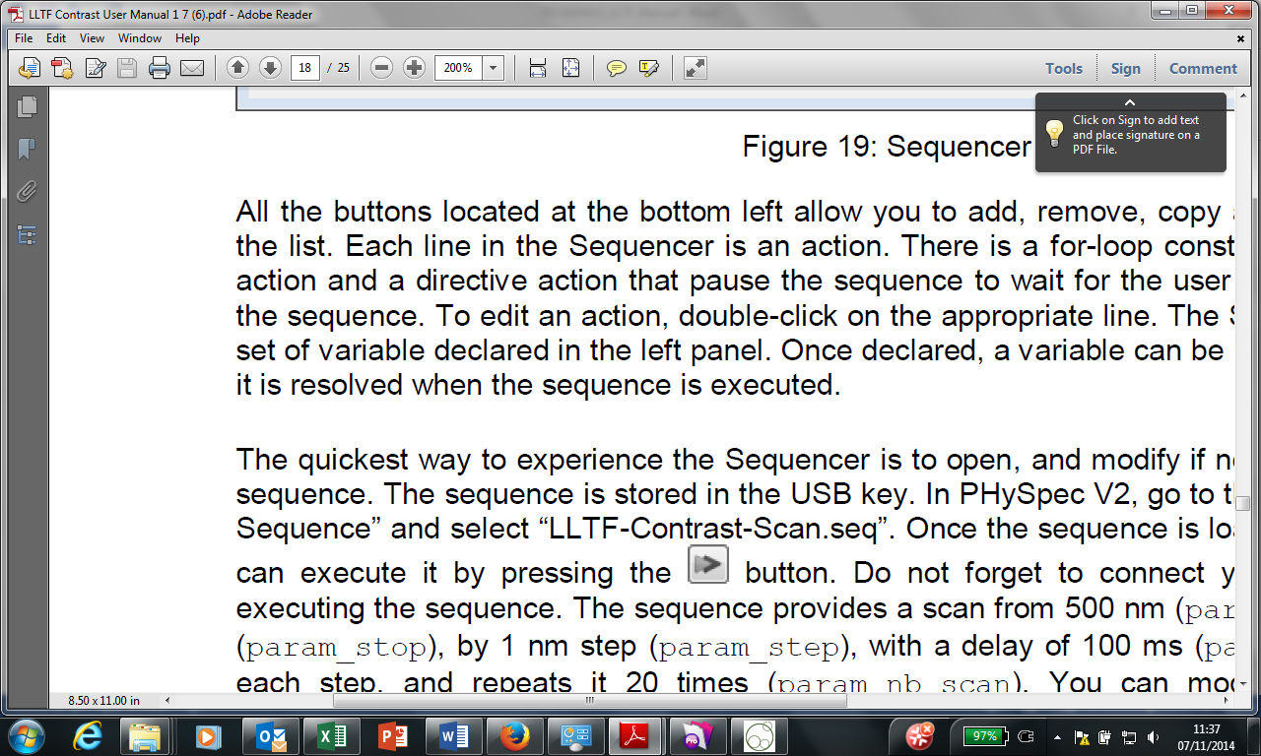 button. Do not forget to connect your instrument before executing the sequence. The sequence provides a scan from 500 nm (param_start) to 800 nm (param_stop), by 1 nm step (param_step), with a delay of 100 ms (param_delay) between each step, and repeats it 20 times (param_nb_scan). You can modify the value of any parameters in the sequence to adapt to your needs.

## Variables

You can define textual and numerical variables. Those variables can be useful in sequences incorporating advanced logic, for example incrementing a parameter in a for-loop construct. They can be used as inputs for all available actions. You can create a variable using 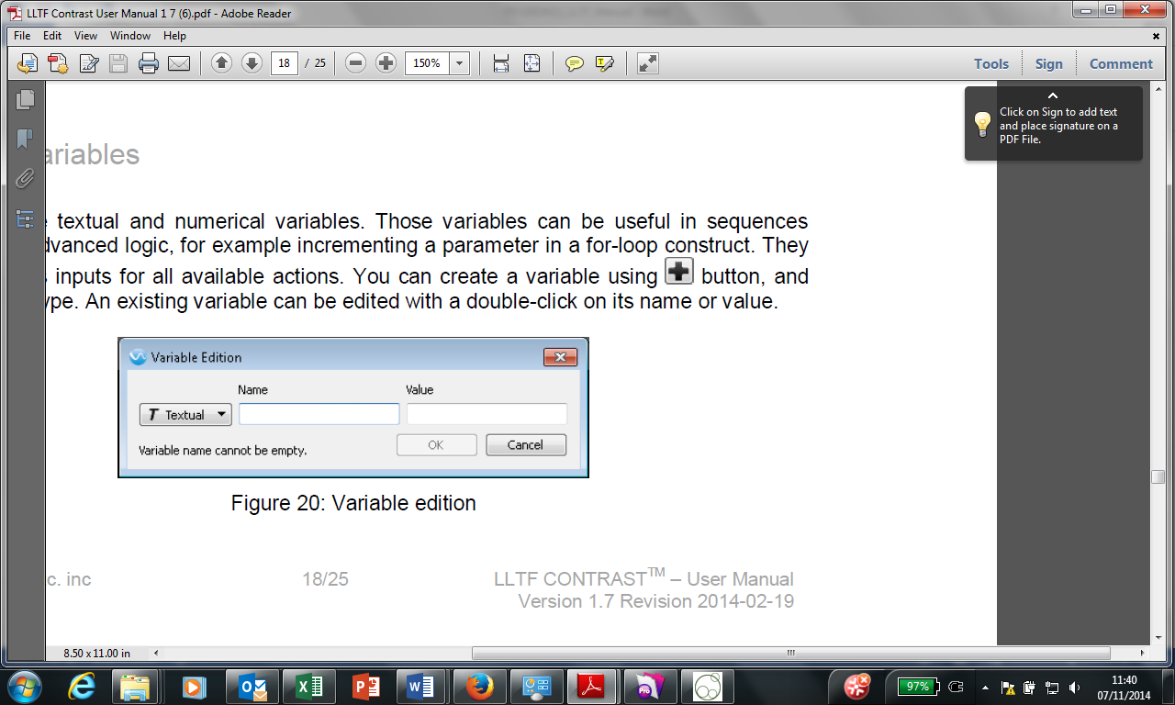 button, and then select its type. An existing variable can be edited with a double-click on its name or value.



Figure H‑2

## Actions

Actions are the core of the sequencer. An action can be an acquisition , an instrument command or setting (e.g wavelength), a data processing, or a logical statement.



Figure H‑3

The table below describes all the buttons located at the bottom left of the sequencer.

|  |  |
| --- | --- |
|  | Add a new sequencer action. A menu will roll down with all the possibilities according to the loaded system. |
|  | Delete currently selected action. |
|  | Duplicate currently selected action. |
|  | Move up currently selected action. |
|  | Move down currently selected action. |
|  | Run (execute) only currently selected action. The progression of the action will be indicated in the status column. |
|  | Run (execute) all actions in the sequence. The progression of each action will be indicated in the status column. |
|  | Abort a currently running sequence. |

The *add* menu includes several types of action:

**System**

Those actions are related to the system currently connected. They are used to modify the system state or to acquire data. The validity of the parameters is only checked when the sequence is executed.

**Data manipulation**

Allow to import/export/unload data.

**Processing**

There are various processing actions available such as rectification or registration auto-detection.

**Directive**

When the sequence reaches this action, a popup appears showing a user-defined message. It can be useful when you need a human intervention, like moving a sample. The sequence will continue when the user presses “*ok”*.

**Delay**

Specify a delay in seconds.

**For-Loop**

All actions in-between “Loop” and the “End For” actions are executed the number of times indicated in the Loop action.

**Variable Edition**

|  |  |
| --- | --- |
| Variable Edition is the only action type that affect a variable value during the sequencer execution. Text variable edition only supports concatenation (‘+’) of the following types of entry: | **Example** |
| * Static text between quotes | “Lorem Ipsum” |
| * Reference to textual variable | textVarName |
| * Reference to numeric variable | numVarName |
| * Reference to the number of cube(s) currently loaded (imaging applications only) | @CubeCount |
| * Reference to the number of image(s) currently loaded (imaging applications only) | @ImageCount |
| * Explicitly converted arithmetic equation | **STR(**(34 + numVarName / numVarName**)** |



Figure H‑4

Numerical variable edition supports basic arithmetic operations with the following operator “+, -, /, *” on numerical entries, numerical variables, reference to the number of loaded cube(s) and references to the number of loaded image(s).



Figure H‑5

# Maintenance

### Basic cleaning instructions

Your instrument is designed to provide years of reliable service. There is no specific need to clean the instrument. If needed (dust, spot), basic cleaning instructions consist to:

* Remove dust on the enclosure with dry cloth;
* Remove stains on the enclosure with a cloth damped with soapy water or isopropanol;
* The Input / Output port doesn’t need to be cleaned.

WARNING: NEVER SPRAY ANYTHING INSIDE THE INSTRUMENT (WATER SPRAY AND/OR DUST SPRAY TYPE)

###### Storage conditions

When the instrument is not in use, these conditions should be respected:

* In order to reduce the accumulation of dust in the instrument and especially on the optics, block the optical port;
* Keep humidity level low;
* Avoid thermal shocks;
* The storage temperature should be between 0⁰C and 50⁰C.

# Troubleshooting

Your instrument is designed to provide years of reliable service. If you are experiencing a problem, reviewing this section before contacting us will save you time and help you eliminate some simple errors that can be easily corrected. Some of the most common difficulties that may be encountered are listed below. With each, some suggestions are given that will help correcting the problem for most cases. If you need assistance in resolving a problem, feel free to contact us.

*Fianium Ltd, Unit 20 Compass Point, Ensign Way, Hamble, Southampton, UK SO31 4RA*

*Tel - +44 (0)2380 458776, Fax – +44 (0)2380 458734*

*E-mail –* [*support@fianium.com*](mailto:support@fianium.com)*, Website –* [*www.fianium.com*](http://www.fianium.com)

###### PHySpec does not detect your instrument

* Make sure the USB connection is physically linked from your computer to your instrument.
* Check that the power cord is connected to power. Double check that the switch is on.
* Check if the COM port is opened. Click on Communication in the top menu of PHySpec and select Configuration (or press F10 on your keyboard), verify that your device has been found (See Starting and Configuring the Instrument).
* If you click on Device list… (F11) under Device in the top menu, the Device Explorer window will appear (See Device Explorer window). You will then be able to verify that every device has been detected.
* USB drivers may not be correctly installed. Make sure that USB Serial port (COMx) is available under Port (COM and LPT) from Windows’ Device Manager. If not, check the USB connection and reinstall the USB drivers.

###### Are the environmental and maintenance conditions respected?

* Condensation can harm the optical path, the throughput and the electrical board.

###### Are all the connections working?

* Unplug all your connections and plug them again.